[Source http://3dprintingindustry.com/3d-printing-basics-free-beginners-guide/](http://3dprintingindustry.com/3d-printing-basics-free-beginners-guide/)

**Bibliography**

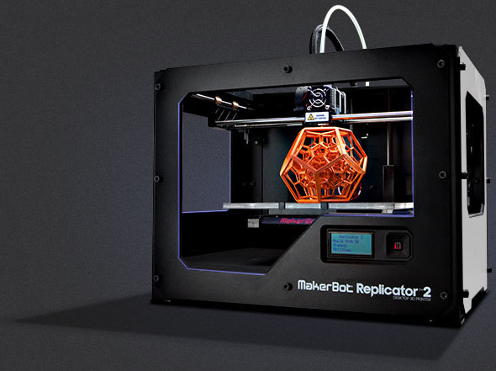

Image from <http://hothardware.com/News/MakerBot-Wants-To-Put-3D-Printers-In-Every-School-In-America-With-MakerBot-Academy-Initiative/>

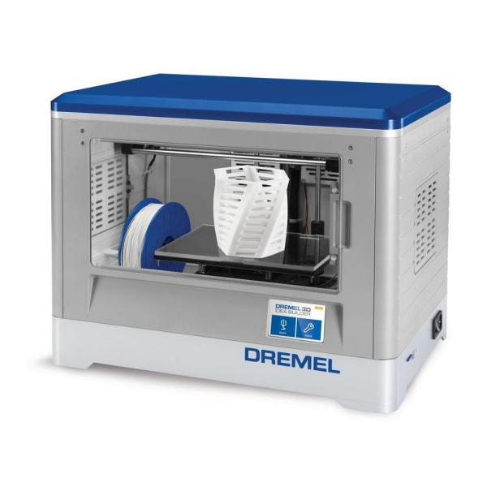

Image from

<http://www.homedepot.com/p/Dremel-Idea-Builder-3D-Printer-3D20-01/205448581>

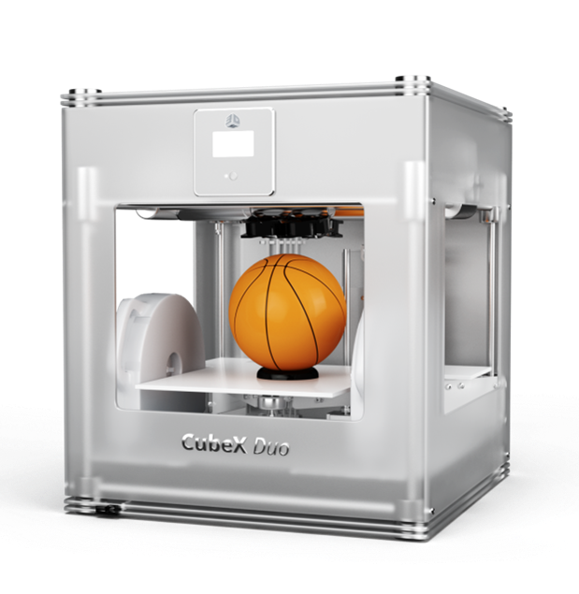Image from http://yunhobby.blogspot.com/2013/02/going-to-have-my-first-3d-printer.html